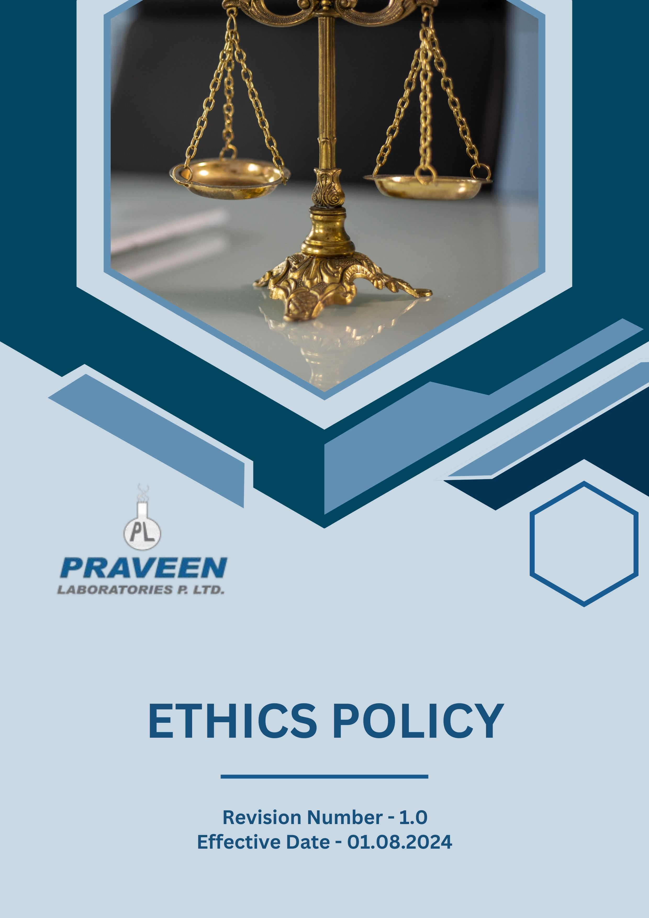

Table Of Contents

1. Overview 3
2. The PRAVEEN LABORATORIES PVT. LTD. Strategy 3
3. Applicability 3
4. Primary Objectives 4
5. Journey to Responsibility: PRAVEEN LABORATORIES PVT. LTD. Commitment 5
6. Ethical Guidelines 7
7. Actions Regarding Violation of the Policy 8
8. Responsibility of this Policy 9
9. Governance 10
10. Do’s & Don’ts 10
11. Reporting Section 12
12. Covered SDGs 12
13. Review Mechanism 13
14. Employee Acknowledgement Form: Ethics Policy 14

Overview
Praveen Laboratories Pvt. Ltd. is dedicated to conducting its business with integrity, transparency, and accountability. The company acknowledges its duty to maintain the highest ethical standards across all operations. Ethical behaviour is essential for fostering trust among customers, employees, suppliers, and stakeholders. The Ethics Policy acts as a guiding framework for ethical decision-making within the organization, outlining commitments to compliance, fair business practices, human rights, environmental responsibility, data privacy, and whistleblower protection.

The PRAVEEN LABORATORIES PVT. LTD. Strategy
At Praveen Laboratories Pvt. Ltd., we integrate ethical considerations into our daily operations and decision-making processes. Our approach is rooted in embedding ethical values into corporate culture, which is essential and can be achieved through effective leadership and employee engagement. Regular risk assessments should be conducted to identify and mitigate potential ethical issues. Additionally, providing training programs enhances awareness and understanding of ethical standards. It is crucial to establish clear policies and procedures that guide ethical behaviour across all business functions. Collaborating with industry partners, NGOs, and regulatory bodies helps organizations stay aligned with global ethical standards.

We set annual goals, develop necessary capabilities, and commit appropriate resources to achieve this policy through innovation, operational efficiency, and aligning Praveen Laboratories Pvt. Ltd. supply chain with this policy.

Applicability
This policy applies to all employees, stakeholders, contractors, partners, customers, contractual workers, and anyone acting on behalf of following sites:
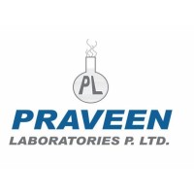 | Praveen Laboratories Pvt. Ltd.
 | Office Address: 720, Golden Point, Falsawadi, Ring Road, Surat-395003, Gujarat, India
 | Factory Address: BlockNo.206, Village: Jolwa, Taluka: Palsana, Dist: Surat‐394305, Gujarat, India
 | http://www.praveenlabs.com/

Primary Focus Areas
- Compliance with Laws and Regulations
All relevant National and International laws and regulations are closely adhered to by Praveen Laboratories Pvt. Ltd. We guarantee compliance with labor laws, environmental rules, anti-corruption laws, and ethical business practices. Praveen Laboratories Pvt. Ltd. has established a key commitment to ethical business practices.

- Bribery:
- We uphold strict anti-corruption policies and ensure that all business dealings are conducted with honesty and transparency.
- Conduct regular internal audits and risk assessments to identify and mitigate corruption risks.

- Strengthening Data Protection:
- We uphold the highest standards of data privacy and security to protect the personal and business information of our employees, customers, and partners.
- Implement encryption and access control to protect sensitive information from unauthorized access.

- Conflict of Interest:
- Employees need to be aware of the potential for the conflict of interest to arise and should always act in the best interest of Praveen Laboratories Pvt. Ltd.
- Require employees to submit an annual Conflict of Interest Disclosure Statement, identifying any personal or financial relationships that may pose a conflict.

- Fraud:
- Develop clear guidelines on ethical behaviour, fraud risks, and reporting procedures to empower employees to act with integrity.
- Establish a confidential whistleblower program to enable employees and stakeholders to report suspected fraud anonymously and without retaliation.

- Financial Crime:
- Conduct mandatory Anti- Money Laundering (AML) training programs for employees.
- Establish a risk assessment framework to continuously evaluate and manage AML-related risks within business operations.

- Unfair Trade Practices:
- Promote a culture of integrity and ethical business conduct, ensuring that employees understand the importance of free and fair competition.
- Require all suppliers, distributors, and business partners to comply with Praveen Laboratories Pvt. Ltd. Anti-Competitive Practices.

- Ensuring Ethical Supply Chains:
- We continuously engage with our suppliers to ensure fair labor practices, responsible sourcing, and ethical procurement.

- Promoting Diversity and Inclusion:
- We foster a workplace that values diversity, promotes equal opportunities, and supports a culture of inclusivity.

Journey to Responsibility: PRAVEEN LABORATORIES PVT. LTD. Commitment
Considering calendar year 2022 as the Baseline year for measuring progress and achievements in our sustainability initiatives.

- Bribery:
- We strive to conduct comprehensive anti-corruption risk assessments covering 100% of business functions annually by 2026.
- We ensure that 100% completion rate for annual anti-corruption training among all employees by 2026.
- We plan to achieve that 100% of new third-party partners undergo thorough anti-corruption due diligence before engagement by 2026.
- We are committed to maintain a strict policy of zero tolerance towards any form of corruption. This unwavering stance reflects our dedication to integrity and ethical conduct in all our operations.

- Fraud:
- We strive to conduct comprehensive fraud risk assessments covering all business functions annually by 2026.
- We plan to achieve a 100% completion rate for annual fraud awareness training among all employees by 2026.
- We ensure that 100% of new suppliers and business partners undergo thorough fraud risk assessments before engagement by 2026.

- Financial Crime:
- We are committed to conducting comprehensive annual Anti-Money Laundering (AML) risk assessments covering 100% of business functions, ensuring full compliance with regulatory standards by 2026.
- We aim to achieve a 100% completion rate for annual Anti-Money Laundering (AML) training among all employees by 2026, fostering a culture of compliance and awareness.
- We will ensure that 100% of new third-party partners undergo thorough AML due diligence before engagement by 2026, mitigating financial crime risks in our operations.

- Conflict of Interest:
- We strive for a workplace with high ethical standards by achieving a 100% completion rate for conflict-of-interest training among all employees by 2026.
- We are committed to addressing and resolving at least 90% of reported conflict-of-interest incidents within 30 days of disclosure by 2026, enhancing transparency and accountability.
- We will conduct annual audits of conflict-of-interest disclosures, ensuring 100% of disclosed cases are reviewed, to identify patterns and strengthen our internal controls, fostering a culture of integrity by 2026.

- Information Security:
- We prioritize cybersecurity awareness, ensuring 100% of employees complete annual information security training by 2026.
- To strengthen our security infrastructure, we will conduct regular vulnerability scans and remediate at least 90% of identified high-risk vulnerabilities within 15 days by 2026.
- We will implement Multi-Factor Authentication (MFA) for 100% of employees accessing sensitive systems by 2026, reinforcing data security.
- We will deploy data loss protection solutions to monitor and safeguard 100% of sensitive data by 2026, ensuring data integrity and confidentiality.

- Ethical Supplier Certification:
- We seek to achieve maximum of our suppliers are certified under recognized ethical standards, such as Fair Trade or equivalent, by 2026.
- We plan to collaborate with ethically certified suppliers which strengthens the integrity of the supply chain by 2026.

Ethical Guidelines

Praveen Laboratories Pvt. Ltd. has established the following ethical guidelines to ensure compliance with our Ethics Policy. These guidelines apply to all employees, business partners, and stakeholders.

- Integrity and Honesty
- Employees must be honest in all business dealings and avoid deceptive practices.
- Example: If a supplier provides substandard raw materials, employees must report it rather than falsifying quality reports to meet production targets.

- Fair Competition
- Employees must compete fairly and not engage in anti-competitive practices such as price-fixing or market manipulation.
- Example: A sales team member must not spread false information about a competitor’s product to gain a market advantage.

- Conflict of Interest
- Employees must disclose any personal or financial interest that could influence their business decisions.
- Example: An employee who has a financial stake in a vendor must report the conflict before approving contracts with that vendor.

- Workplace Respect and Inclusion
- Discrimination, harassment, and workplace bullying are strictly prohibited.
- Example: All hiring decisions must be based on skills and experience rather than personal biases related to gender, race, or background.
- Anti-Bribery and Corruption
- Employees must not offer, accept, or solicit bribes, kickbacks, or any improper payments.
- Example: An employee must refuse a gift of high value from a supplier seeking preferential treatment in future contracts.

- Confidentiality and Data Protection
- Employees must safeguard customer, employee, and company data from unauthorized access or disclosure.
- Example: Customer data must not be shared with third parties without proper authorization.

- Whistleblower Protection
- Employees who report ethical violations in good faith will be protected from retaliation.
- Example: If an employee reports fraudulent financial practices, they must not be demoted or dismissed for making the report.

Actions Regarding Violation of the Policy
Praveen Laboratories Pvt. Ltd. takes violations of this Ethics Policy very seriously and has established a structured process to handle them effectively. The following actions will be taken in cases of violations, enforcing a strict approach to handling violations of this Ethics Policy. Actions taken against violations include:

- Investigation and Review: All reported violations will be thoroughly investigated by the Compliance Manager and relevant authorities within the company.
- Corrective Actions: Depending on the severity of the violation, corrective actions will be implemented, including policy reinforcement, additional training, or procedural adjustments.
- Disciplinary Measures: Employees or stakeholders found guilty of ethical misconduct may face disciplinary actions such as warnings, suspension, or termination of employment or business relationships.
- Legal Consequences: In cases involving fraud, corruption, or serious ethical breaches, legal action may be taken in accordance with applicable laws and regulations.
- Whistleblower Protection: Any employee or stakeholder reporting violations in good faith will be protected from retaliation.
- Regular Monitoring and Audits: Ethical compliance audits will be conducted periodically to ensure adherence to company policies and standards.

Responsibility of this Policy
- Managing Director
- Oversee the implementation and effectiveness of the Ethics Policy.
- Ensure that ethical risks are identified and mitigated at the highest level.

- Compliance Officer
- Developing and executing ethical policies in alignment with corporate goals.
- Monitoring compliance with ethical commitments across the organization and reporting on ethics progress to the Board and stakeholders.

- Departmental Head
- Communicate the importance of ethical behaviour to employees and monitor compliance with the Ethics Policy in daily operations.
- Identify potential ethical risks and address them proactively and encourage employees to participate in ethics training and awareness programs.

- Employees
- Familiarize themselves with and adhere to the Ethics Policy and contribute to an ethical workplace culture by treating colleagues, customers, and stakeholders with respect.
- Report any suspected ethical violations through proper channels and act with integrity in all professional dealings.

Governance
Praveen Laboratories Pvt. Ltd. upholds robust governance by integrating ethical and environmental responsibility into its corporate framework. Leadership plays a pivotal role in ensuring compliance, fostering transparency, and maintaining the highest standards of accountability. A dedicated compliance team actively oversees adherence to ethical guidelines, proactively identifying and mitigating potential risks. Regular audits and evaluations are conducted to assess policy effectiveness and drive continuous improvement.

The organization cultivates a culture of ethical business practices at all levels, prioritizing integrity, fair competition, and responsible decision-making. Employees are empowered to voice concerns through a well-structured grievance mechanism, ensuring that ethical violations are addressed promptly and without fear of retaliation. Collaboration with industry partners, regulatory bodies, and stakeholders further reinforces the company’s unwavering commitment to sustainability, corporate responsibility, and long-term ethical excellence.

Do’s & Don’ts
To ensure ethical governance is upheld at all levels, the following guidelines outline the appropriate and inappropriate actions for employees, managers, directors, and external stakeholders.

Anti-Corruption and Fraud Prevention
✅ Do’s
- Report any suspicious activities or bribery attempts to the Compliance Officer.
- Maintain clear and transparent records of all financial transactions.
- Adhere to all anti-corruption policies and training requirements.
- Refuse gifts or incentives from suppliers that may influence business decisions.
❌ Don’ts
- Do not offer or accept bribes in any form.
- Do not falsify or manipulate financial records.
- Do not engage in fraudulent business dealings or misrepresent facts.
- Do not ignore or withhold information regarding corruption risks.

Conflict of Interest Management
✅ Do’s
- Disclose any personal or financial relationships that could create a conflict of interest.
- Seek approval before engaging in any external business relationships related to Praveen Laboratories Pvt. Ltd.
- Follow company procedures for reporting conflicts of interest.
❌ Don’ts
- Do not make decisions that personally benefit you at the expense of the company.
- Do not engage in business with direct competitors without approval.
- Do not misuse company resources for personal gain.

Money Laundering Prevention
✅ Do’s
- Report any suspicious transactions to the compliance department.
- Conduct due diligence before engaging with new business partners.
- Maintain accurate financial records and transaction logs.
❌ Don’ts
- Do not process or approve transactions that lack clear business justification.
- Do not ignore red flags related to suspicious financial activities.
- Do not engage in structuring transactions to evade reporting requirements.

Anti-Competitive Practice Avoidance
✅ Do’s
- Compete fairly and ethically in the marketplace.
- Follow all applicable competition laws and regulations.
- Ensure transparency in negotiations and pricing strategies.
❌ Don’ts
- Do not engage in price-fixing, bid-rigging, or market allocation schemes.
- Do not discuss competitive pricing strategies with competitors.
- Do not misuse market influence to eliminate competition unfairly.

Information Security and Data Protection
✅ Do’s
- Follow company cybersecurity policies to protect sensitive data.
- Use strong passwords and enable multi-factor authentication where required.
- Report any suspicious emails, phishing attempts, or data breaches immediately.
❌ Don’ts
- Do not share confidential company data with unauthorized individuals.
- Do not use personal devices to store or transmit company-sensitive information.
- Do not click on unknown or suspicious links in emails or messages.

Reporting Section
- Annual Public Ethics Reporting:
- External reporting is conducted annually to communicate our ethical performance to stakeholders, including employees, customers, investors, and regulatory bodies.
- Reports are prepared in accordance with internationally recognized standards such as the United Nations Global Compact (UNGC) and the Global Reporting Initiative (GRI) guidelines.

- Supplier Ethics Compliance Reporting:
- We require suppliers to submit annual reports on their ethical compliance, including any corrective actions taken.
- Audits and third-party assessments are conducted to verify compliance with our Supplier Code of Conduct.

- Stakeholder Engagement:
- We actively engage with employees, suppliers, and other stakeholders to gather feedback, address concerns, and foster transparency in our ethical practices.
- Regular stakeholder meetings and surveys help assess the effectiveness of our ethics initiatives and inform continuous improvement efforts.

- Grievance Mechanisms:
- A formal grievance mechanism is in place to ensure employees and external stakeholders can report violations confidentially and without fear of retaliation.
- Grievance reports are reviewed by the Compliance Manager and addressed according to established procedures.

Covered SDGs





Review Mechanism

- The Compliance Officer reviews this policy annually to ensure alignment with changing regulatory requirements, industry best practices, and stakeholder expectations.
- Company can also change or review policy if any necessary changes is required.
- Updates to the policy are communicated internally, and relevant training is provided to ensure awareness and compliance with ethical standards.

(Signature)
Approved By: General Manager
Next Review Date: 31-07-2025

Employee Acknowledgement Form: Ethics Policy

I acknowledge that I have received, read, and understood PRAVEEN LABORATORIES PVT. LTD. Ethics Policy. I am aware of the company's commitment to upholding ethical standards, promoting a diverse and inclusive workplace, and ensuring the protection of human rights across all operations and supply chains.
I understand my role in supporting this policy, including complying with all applicable laws and regulations, respecting human rights, and fostering a safe and inclusive work environment. I agree to adhere to ethical practices in my daily work, report any ethical concerns, and contribute ideas for continuous improvement.
By signing below, I confirm my commitment to upholding PRAVEEN LABORATORIES PVT. LTD. Ethics Policy and supporting the company’s efforts in maintaining ethical practices.

Employee Name:
Employee Signature:
Date:

